**Thread Pools in Java**

Server Programs such as database and web servers repeatedly execute requests from multiple clients and these are oriented around processing a large number of short tasks. An approach for building a server application would be to create a new thread each time a request arrives and service this new request in the newly created thread. While this approach seems simple to implement, it has significant disadvantages. A server that creates a new thread for every request would spend more time and consume more system resources in creating and destroying threads than processing actual requests.

Since active threads consume system resources, a [JVM](https://www.geeksforgeeks.org/jvm-works-jvm-architecture/)creating too many threads at the same time can cause the system to run out of memory. This necessitates the need to limit the number of threads being created.

**Advantage of using Thread Pool:**

**A thread pool reuses previously created threads to execute current tasks and offers a solution to the problem of thread cycle overhead and resource thrashing.** Since the thread is already existing when the request arrives, the delay introduced by thread creation is eliminated, making the application more responsive.

Java provides the Executor framework which is centered around the Executor interface, its sub-interface –**ExecutorService** and the class-**ThreadPoolExecutor**, which implements both of these interfaces.

To use thread pools, we first create a object of ExecutorService and pass a set of tasks to it. ThreadPoolExecutor class allows to set the core and maximum pool size.The runnables that are run by a particular thread are executed sequentially.

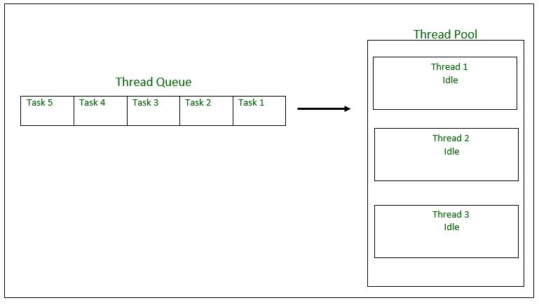

**Executor Thread Pool Methods**

**Method** **Description**

newFixedThreadPool(int) Creates a fixed size thread pool.

newCachedThreadPool() Creates a thread pool that creates new threads as needed, but will reuse previously constructed threads when they are available

newSingleThreadExecutor() Creates a single thread.

**Steps to be followed in creating Thread Pool**

1. Create a task(Runnable Object) to execute

2. Create Executor Pool using Executors

3. Pass tasks to Executor Pool

4. Shutdown the Executor Pool

**Example:**

|  |
| --- |
| **import** java.text.SimpleDateFormat;  **import** java.util.Date;  **import** java.util.concurrent.ExecutorService;  **import** java.util.concurrent.Executors;    // Task class to be executed (Step 1)  **class** Task **implements** Runnable  {  **private** String name;    **public** Task(String s)      {          name = s;      }        // Prints task name and sleeps for 1s      // This Whole process is repeated 5 times  **public** **void** run()      {  **try**          {  **for** (**int** i = 0; i<=5; i++)              {  **if** (i==0)                  {                      Date d = **new** Date();                      SimpleDateFormat ft = **new** SimpleDateFormat("hh:mm:ss");                      System.out.println("Initialization Time for"                              + " task name - "+ name +" = " +ft.format(d));                      //prints the initialization time for every task                  }  **else**                  {                      Date d = **new** Date();                      SimpleDateFormat ft = **new** SimpleDateFormat("hh:mm:ss");                      System.out.println("Executing Time for task name - "+                              name +" = " +ft.format(d));                      // prints the execution time for every task                  }                  Thread.sleep(1000);              }              System.out.println(name+" complete");          }    **catch**(InterruptedException e)          {              e.printStackTrace();          }      }  }  **public** **class** Test  {       // Maximum number of threads in thread pool  **static** **final** **int** MAX_T = 3;    **public** **static** **void** main(String[] args)      {          // creates five tasks          Runnable r1 = **new** Task("task 1");          Runnable r2 = **new** Task("task 2");          Runnable r3 = **new** Task("task 3");          Runnable r4 = **new** Task("task 4");          Runnable r5 = **new** Task("task 5");            // creates a thread pool with MAX_T no. of          // threads as the fixed pool size(Step 2)          ExecutorService pool = Executors.newFixedThreadPool(MAX_T);            // passes the Task objects to the pool to execute (Step 3)          pool.execute(r1);          pool.execute(r2);          pool.execute(r3);          pool.execute(r4);          pool.execute(r5);            // pool shutdown ( Step 4)          pool.shutdown();      }  } |

**Sample Execution**

Output:

Initialization Time for task name - task 2 = 02:32:56

Initialization Time for task name - task 1 = 02:32:56

Initialization Time for task name - task 3 = 02:32:56

Executing Time for task name - task 1 = 02:32:57

Executing Time for task name - task 2 = 02:32:57

Executing Time for task name - task 3 = 02:32:57

Executing Time for task name - task 1 = 02:32:58

Executing Time for task name - task 2 = 02:32:58

Executing Time for task name - task 3 = 02:32:58

Executing Time for task name - task 1 = 02:32:59

Executing Time for task name - task 2 = 02:32:59

Executing Time for task name - task 3 = 02:32:59

Executing Time for task name - task 1 = 02:33:00

Executing Time for task name - task 3 = 02:33:00

Executing Time for task name - task 2 = 02:33:00

Executing Time for task name - task 2 = 02:33:01

Executing Time for task name - task 1 = 02:33:01

Executing Time for task name - task 3 = 02:33:01

task 2 complete

task 1 complete

task 3 complete

Initialization Time for task name - task 5 = 02:33:02

Initialization Time for task name - task 4 = 02:33:02

Executing Time for task name - task 4 = 02:33:03

Executing Time for task name - task 5 = 02:33:03

Executing Time for task name - task 5 = 02:33:04

Executing Time for task name - task 4 = 02:33:04

Executing Time for task name - task 4 = 02:33:05

Executing Time for task name - task 5 = 02:33:05

Executing Time for task name - task 5 = 02:33:06

Executing Time for task name - task 4 = 02:33:06

Executing Time for task name - task 5 = 02:33:07

Executing Time for task name - task 4 = 02:33:07

task 5 complete

task 4 complete

As seen in the execution of the program, the task 4 or task 5 are executed only when a thread in the pool becomes idle. Until then, the extra tasks are placed in a queue.

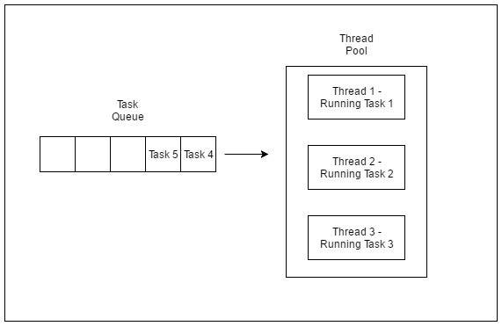

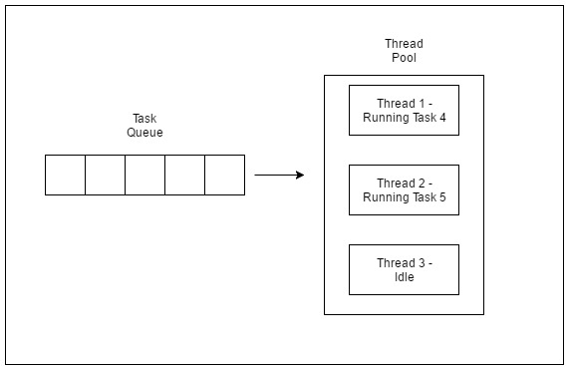

**Risks in using Thread Pools**

* + 1. [**Deadlock**](https://www.geeksforgeeks.org/deadlock-in-java-multithreading/)**:**While deadlock can occur in any multi-threaded program, thread pools introduce another case of deadlock, one in which all the executing threads are waiting for the results from the blocked threads waiting in the queue due to the unavailability of threads for execution.
    2. **Thread Leakage :**Thread Leakage occurs if a thread is removed from the pool to execute a task but not returned to it when the task completed. As an example, if the thread throws an exception and pool class does not catch this exception, then the thread will simply exit, reducing the size of the thread pool by one. If this repeats many times, then the pool would eventually become empty and no threads would be available to execute other requests.
    3. **Resource Thrashing :**If the thread pool size is very large then time is wasted in context switching between threads. Having more threads than the optimal number may cause starvation problem leading to resource thrashing as explained.